

Hackbridge & Beddington Corner
Neighbourhood Development Group
hackbridgeandbc@gmail.com
www.hackbridgendg.com

Mr Nick Lloyd-Davies
Environmental, Housing and Regeneration Services Directorate
24 Denmark Road
Carshalton
SM5 2JG 7 November 2016

Dear Mr Lloyd-Davies

Planning Application No. C2016/74653
WANDLE TRADING ESTATE, HACKBRIDGE

Further to our letter dated 21 July 2016 (see below), we understand that the size of the mill pond has now been confirmed to its original dimensions as seen in drawing no. 13416-PA-001.rev and the land originally given over as compensation for the loss of SINC has also been realised in recent plan no. 1690_0500_E.

However, the position of the bridge still remains different from the original plans. We wish to see this moved back to its original position, furthest east of the mill pond. This maximises the amount of deep water adjacent to Spencer Road Wetlands, which is beneficial to the wildlife and visitor experience.

Yours sincerely

LHorrox

Lysanne Horrox
Chair

Hackbridge & Beddington Corner
Neighbourhood Development Group
hackbridgeandbc@gmail.com
www.hackbridgendg.com

Mr Chris Smith
Environmental, Housing and Regeneration Services Directorate
24 Denmark Road
Carshalton
SM5 2JG 21 July 2016

Dear Mr Smith

Planning Application No. C2016/74653
WANDLE TRADING ESTATE, HACKBRIDGE

Members of the NDG have been involved with this application from the start. We welcome the early engagement with Redrow following their acquisition of the site.

While a number of alterations to the original application were put forward by Redrow, we sought and gained answers to all our concerns regarding changes.

One exception to this relates to promises made in respect of elements of the site backing onto Spencer Wetlands.

We are concerned over the inconsistency of the master plan drawing used in the approved application C2013/68191.

We agree that drawing no. 13416-PA-001-rev is indeed the correct masterplan layout and has been submitted under the banner of ‘amended drawing’ on Sutton Council’s planning portal.

The new S73 changes in application C2016/74653 have reduced the size of the mill pond and changed the access over the pond from the right hand side to the left hand side. It has also removed two areas of land given over as compensation for the loss of SINC. These are important as a buffer zone to Spencer Road Wetlands.

Please see below drawing 13416-PA-001-rev marked up with the areas that have changed.

We do not support this deviation from the original application.

Yours sincerely

LHorrox

Lysanne Horrox
Chair
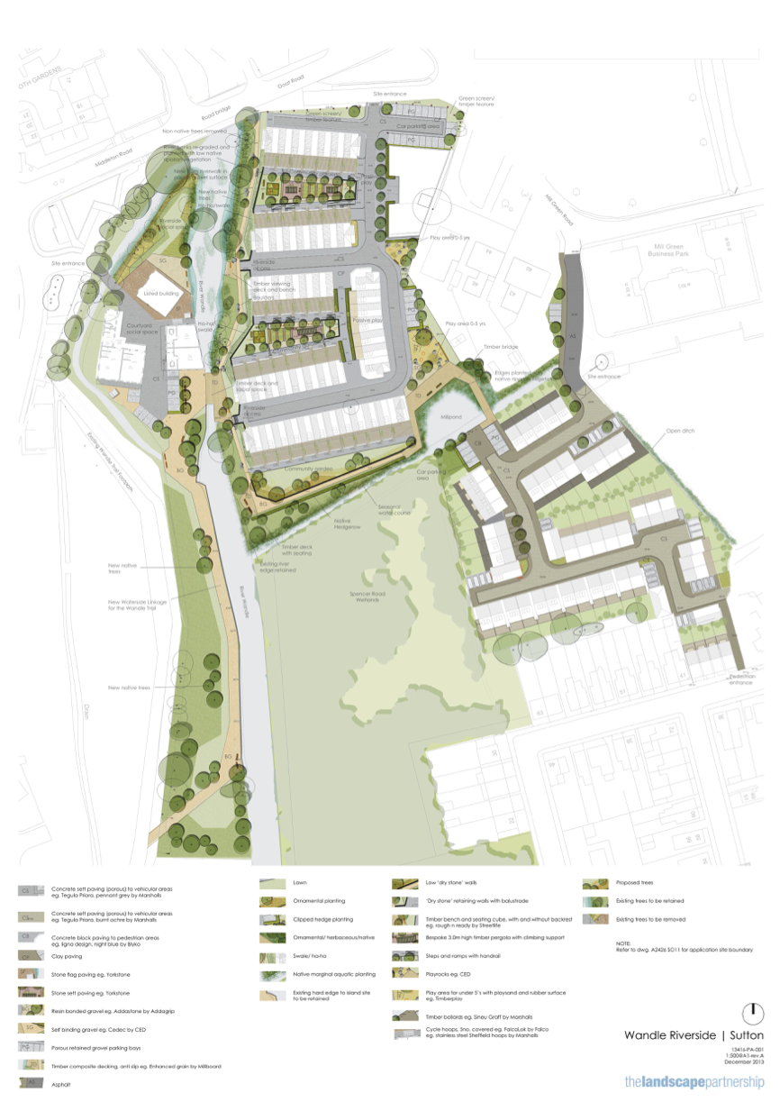
1
2
3

