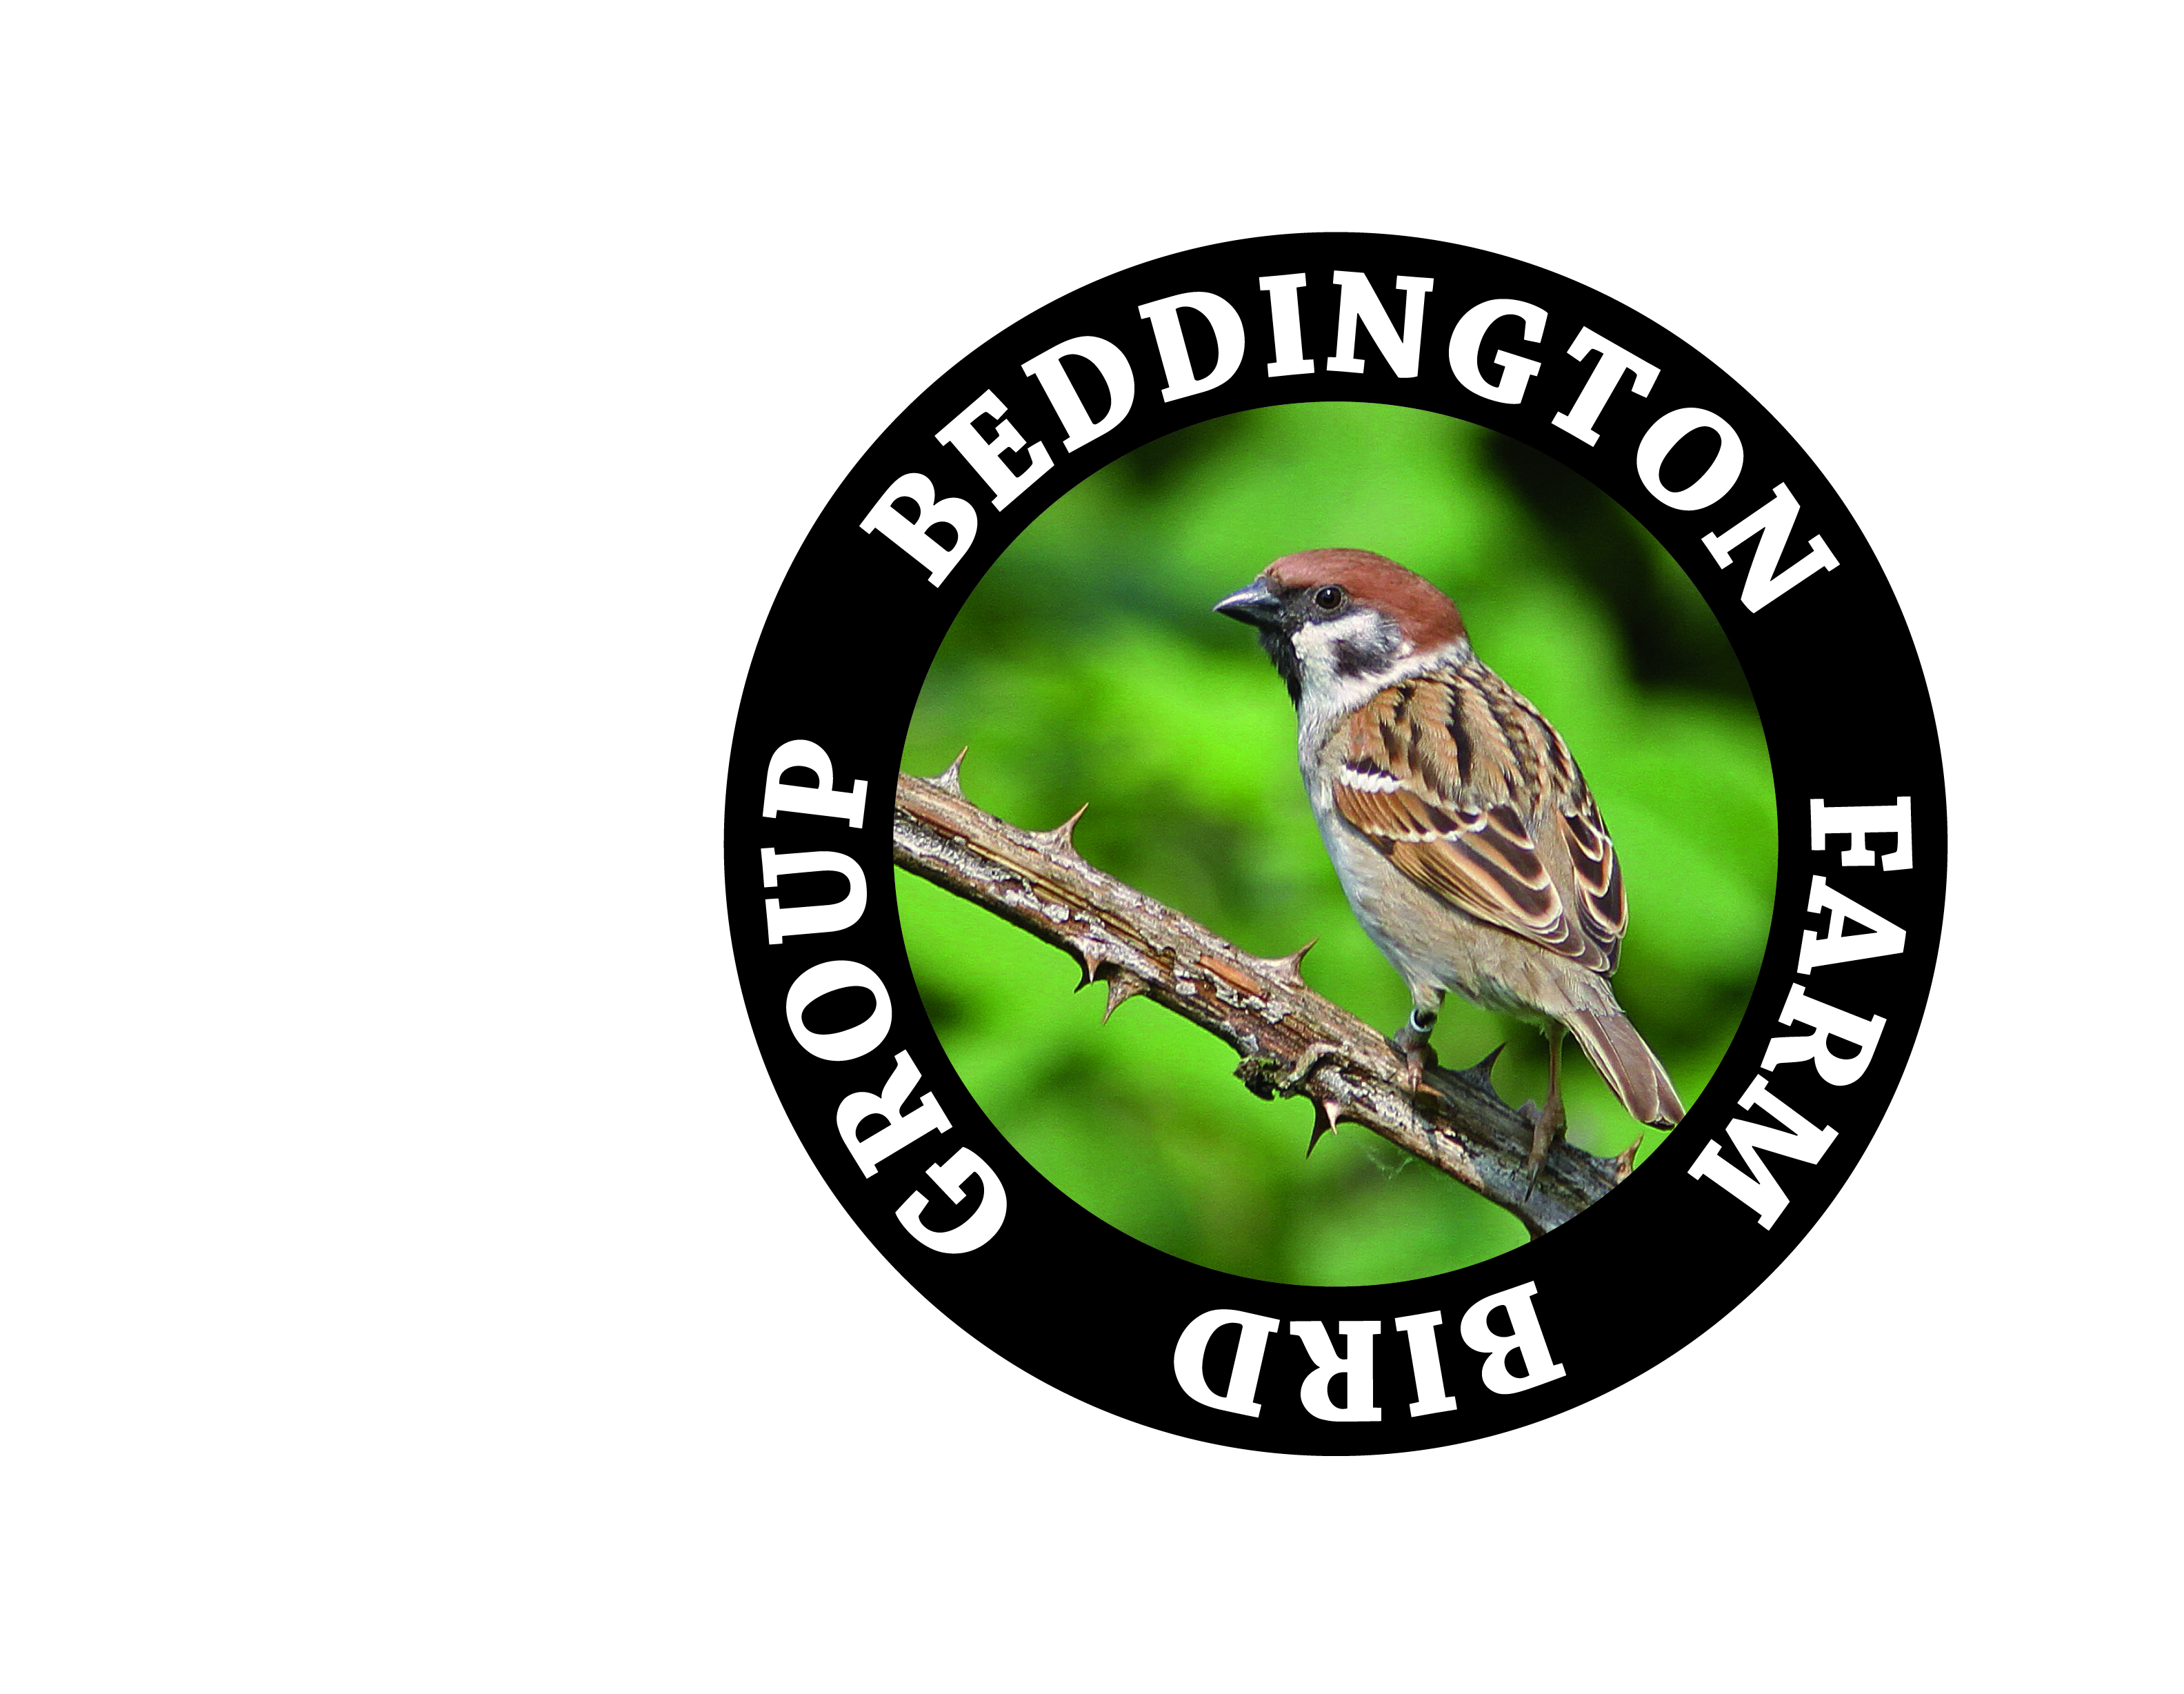
18th September 2012
BEDDINGTON FARMLANDS ERF PLANNING APPLICATION RESPONSE
by
Beddington Farmlands Bird Group (BFBG)

The Beddington Farm Bird Group have been recording birds and nature at Beddington Farmlands for many decades and working through the Conservation Science Group have been closely involved in the restoration programme and the development of Beddington Farmlands for wildlife and people. . The group members come from a wide background and include professional naturalists and conservation workers and work in partnership with the London Wildlife Trust, The RSPB and the Wildfowl and Wetlands Trust.
Our response to the ERF planning application presented here is in two parts
- Objections: Section A refers to comments regarding the content of the application with particular reference to the concerns that:
i) the biodiversity at Beddington Farmlands has been undervalued in the application,
ii) the negative effect of the ERF on the ‘Nature and Country Park’ and the wider Wandle Valley Regional Park is not being fairly represented in the applicants proposal and
iii) the applicant failed to meet the conservation targets set out in previous planning applications and failed to meet their environmental obligations so a fundamental change in the management structure of the restoration is proposed to ensure that any future obligations are met.

- Mitigation: Section B refers to suggestions that the planning committee may care to consider in ensuring that the regional park is optimally delivered and the birds and wildlife populations recover to former (and beyond) levels

- OBJECTIONS

- UNDERSTATEMENT OF BIODIVERSITY WITHIN SUBMITTED PLANNING APPLICATION
We strongly assert that the biodiversity at Beddington Farmlands is greater than presented in the planning application and feel it is important that the planning committee are fully aware of the conservation importance of Beddington Farmlands. Especially we wish to comment on the following areas:

- Reptile Surveys

The reptile surveys carried out by Mouchel and SLR found no Common Lizards in the survey area (including areas adjacent to the proposed ERF). However Common Lizards were reported throughout the survey period under the same survey mats by members of the BFBG. On July 22nd 2011 a gravid female was found under a survey mat at (Survey area 15 – adjacent to the proposed ERF location) indicating breeding on site. Common Lizards were also reported under survey mats north and south of the Main Lake throughout the summer of 2011.

- Bird Surveys
In addition to the bird surveys carried out by ecological consultants e.g. Mouchel and MKA Ecology in 2011, ornithological qualitative data and additional quantitative data are also collected by the BFBG and in conjunction with results from the ecological consultants are reported in an annual Bird Report.
- Species Diversity
The annual bird report records an average of 150 species each year (cf 8.36 of Planning Application Summary stating that regular surveys show 82 bird species)
- Breeding Species
Annual breeding surveys collated by the BFBG between 1999 and 2008 recorded 55-60 species in the breeding season of which an average of 40 species were considered to be breeding with between 512 and 663 territories (cf. 8.36 Planning Application Summary stating 33 species )

- Species of Conservation Concern
The BFBG records show:
255 species of bird recorded on site.
Eight breeding red data list species (list as per 2008) : Lapwing, Skylark, Song Thrush, Starling, House Sparrow, Tree Sparrow, Linnet and Reed Bunting
Ten London Biodiversity Action Plan Species: Grey Heron, Peregrine, Skylark, Sand Martin, Song Thrush, Starling, House Sparrow, Tree Sparrow, Linnet and Reed Bunting
1% threshold winter population Site for Green Sandpiper, Caspian Gull, Lesser Black Backed Gull and Water Pipit

Regular migrant red data list species: Ring Ouzel, Turtle Dove, Spotted Flycatcher, Bullfinch, Black-tailed Godwit, Cuckoo, Yellow Wagtail, Grasshopper Warbler and Lesser Spotted Woodpecker.

- Entomological Surveys
In addition to the 384 species recorded in the invertebrate survey conducted by Colin Plant (and submitted in the planning application) the BFBG also conduct regular invertebrate surveys. Dr Roger Booth has recorded over 260 species of beetle and Peter Alfrey and Derek Coleman have carried out moth surveys recording over 250 species including the discovery of a population of Dewick’s Plusia , potentially the only breeding location in the UK. (Alfrey and Coleman 2012).. Also preliminary results of a Malaise trap survey conducted by Graham Collins and Derek Coleman show there to be up to 500 species of invertebrate on site including further regionally important records.

- Flora
In addition to the phase 1 habitat survey conducted by MKA Ecology the BFBG have conducted additional botanical surveys and have recorded 281 species .

- UNDERSTATEMENT ON THE EFFECT TO WILDLIFE, THE ‘NATURE AND COUNTRY PARK’ AND THE WIDER WANDLE VALLEY REGIONAL PARK
We strongly contest , contrary to the claims of Viridor, that the ERF will indeed have a significant negative impact on the Beddington Farmlands restoration plan, the Wandle Valley Regional Park and the effect to wildlife with particular attention to the following points:

- Loss of MOL, SMI and Wandle Valley Regional Park
The land proposed for the ERF is Metropolitan Open Land, a Metropolitan Site of Importance for Nature Conservation (SMI) and will become part of the Wandle Valley Regional Park. Given the conservation status of the land any loss of such land is obviously detrimental from a conservation perspective. As suggested in PSS 5:192 it is likely that the area proposed for the ERF (currently been given temporary planning permission for waste management) will never be returned to a green site so this loss of MOL is likely to be permanent (and is certainly a loss until at least 2042) so mitigation for this loss is essential.
- Incompatible with a ‘Nature and Country Park’
An incinerator within the centre of ‘nature and country park’ is inconsistent and incompatible with the ethos of a nature and country park. It is acknowledged that a brown roof on part of the development will provide some habitat for invertebrates but that does not adequately compensate for the loss of habitat generated by the development of the ERF.

The claim that the ERF development will bring forward the development of the restoration is also contested in that the original 1995 planning permission was granted on the basis that the park be delivered in 2015, so the restoration is already late. Also within the planning application there are numerous caveats regarding the public access implying that due to operational and health and safety reasons public access may not be guaranteed within the suggested time frames.

- A Significant Compromise to the Wandle Valley Regional Park
Beddington Farmlands forms one of the main focal points of the wider Wandle Valley Regional Park. The social and economic opportunities within the park include educational (outdoor activities/classes, biological studies), recreational (photography, cycling, running, birding etc) , health benefits (cycling, running, walking etc) and commercial opportunities around the eco-industry. Any compromise in the aesthetic and ecological value of the restoration at Beddington Farmlands is also a compromise on the wider aspirations for the Wandle Valley Regional park. The social and economic benefits of the ERF need to be weighed against the loss of social and economic benefits by compromising the Wandle Valley Regional Park. We strongly argue that Beddington Farmlands should be developed with sustainable industry, education and health as the top priorities.

- Understatement of ecological importance of ERF proposed site
The planning application refers to the loss of the MOL in terms of its current state for baseline comparison. However this land was designated for Wetland Grassland and if this forms the baseline comparison then the ecological loss is much greater then represented. The estimated loss of wet grassland is approximately 30%.

- Significant impact on nationally important population of Tree Sparrow
18% of the population of Tree Sparrows will need to be displaced to build the ERF. The population is currently going through a bottle neck (due to the very wet summer of 2012) so any further negative impacts could be highly significant.

- Loss of important ecological habitat in constructing the new access road
The proposed route of the new access road will result in the loss of a hedgerow, reed bed and stream. This habitat has breeding Reed Buntings (CMP target species), Reed Warblers and Sedge Warblers. Mitigation for the loss of this habitat is required for consistency with the CMP if the planning permission is granted.

- Impact on reptile population
Common Lizards were found by the BFBG in the area immediately adjacent to the ERF site. This population was un-recorded by the consultant ecologists.

- CONCERNS ABOUT THE ABILITY OF VIRIDOR TO DELIVER CONSERVATION AND RESTORATION TARGETS CONSIDERING PAST EXPERIENCE
Viridor have exhibited an inability to be able to meet their conservation and restoration obligations that were set out in the past so there is no reason to believe that the new conservation and restoration targets that they propose in the ERF application will be any more successful. This would require a fundamental change in the management of the restoration and implementation of the Conservation Management Scheme.

- Delay in Restoration Delivery
Many particulars of the restoration plan have been significantly delayed (see table 1)

Table 1 Approximate year of restoration with actual dates
 | 1995 application | 2005 application | Actual date of restoration
Northern Lake | 2000 | # | 2000 and 2009
Southern Lake | 2003 | # | 2009
Reedbed in SE | 2004 | # | Not restored; now proposed to be wet grassland
Reedbed in southern lake | * | * | Attempted in 2010 and 2011
Wet grassland | 2011 | 2011 | To be restored
Acid grassland | 2003 onwards | 2021 onwards | To be restored
Neutral grassland | * | 2008 onwards | Some restoration none complete
* = not proposed so no date
# = no date since the 2005 application assumed that they had already been created
- The decline in the Conservation Management Plan Target Species
Most alarmingly the previous Conservation Management Plan has failed significantly and the target conservation species have overall experienced decline (see table 2-4)
Table 2 Breeding pairs of the target species for selected years
 | 1995 | 2000 | 2005 | 2010
Little Ringed Plover | 1 | 1 | 1 | 0
Ringed Plover | 0 | 1 | 0 | 0
Lapwing | 11 | 18 | 22 | 14
Redshank | 4 | 1 | 2 | 0
Common Tern | 0 | 0 | 0 | 0
Yellow Wagtail | 5 | 0 | 0 | 0
Sedge Warbler | 11 | 25 | 1 | 2
Reed Warbler | 31 | 19 | 13 | 32
Whitethroat | 73 | 76 | 66 | 55
Tree Sparrow | 83 | 52 | 75 | 80
Reed Bunting | 23 | 17 | 5 | 3
The target wintering species are shown in Table 3. Teal, Lapwing, Snipe and Water Pipit have all shown declines of varying degrees. Shoveler and Green Sandpiper have maintained their numbers.
Table 3 Peak number of the target species for selected winters (October-March)
 | 1995/96 | 2000/01 | 2005/06 | 2010/11
Teal | 830 | 600 | 400 | 350
Shoveler | 150 | 115 | 110 | 150
Lapwing | 165 | 150 | 120 | 65
Snipe | 35 | 35 | 30 | 25
Green Sandpiper | 9 | 13 | 14 | 12
Water Pipit | 5 | 10 | 2 | 3

Table 4 List of bird species which have overall declined at Beddington Farmlands since 1998 and the commencement of landfill and restoration
Species | Suggested reasons for decline
Great Crested Grebe | Reduction in wetland habitat. Loss of deep open water.
Wigeon | Reduction in wetland habitat.
Teal | Reduction in wetland habitat.
Mallard (dependent on analysis method) | Reduction in wetland habitat.
Shoveler (data from WEBS counts since 2007) | Reduction in wetland habitat.
Pochard | Reduction in wetland habitat. Loss of deep open water.
Tufted Duck | Reduction in wetland habitat.
Goldeneye | Reduction in wetland habitat. Loss of deep open water.
Ruddy Duck | DEFRA cull
Kestrel | Loss of feeding habitat.
Pheasant | Loss of suitable habitat.
Little Ringed Plover | Loss of suitable habitat. Predation.
Ringed Plover (CMP target species) | Reduction in wetland habitat
Lapwing (CMP target species) | Targeted conservation methods initially succeeded but now the species is in decline.
Little Stint | Reduction in wetland habitat.
Curlew Sandpiper | Reduction in wetland habitat.
Dunlin | Reduction in wetland habitat.
Ruff | Reduction in wetland habitat.
Snipe | Reduction in wetland habitat.
Spotted Redshank | Reduction in wetland habitat.
Redshank (CMP target species) | Reduction in wetland habitat.
Greenshank | Reduction in wetland habitat.
Common Sandpiper | Reduction in wetland habitat- favourable response to re-landscaping of lake.
Common Tern (CMP target species) | Reduction in wetland habitat.
Black Tern | Reduction in wetland habitat.
Turtle Dove | National decline.
Cuckoo | National decline.
Common Swift | National decline.
Lesser Spotted Woodpecker | National decline.
Skylark | Loss of breeding population in recent years. Reason uncertain.
House Martin | National decline.
Meadow Pipit | National decline. Habitat loss.
Yellow Wagtail (CMP target species) | Reduction of wetland habitat. Removal of livestock.
Pied Wagtail | Reduction in wetland habitat.
Whinchat | National decline. Habitat loss.
Song Thrush | National decline.
Sedge Warbler | Reduction in wetland habitat.
Reed Warbler | Reduction in wetland habitat. Loss of beds of hemlock in particular.
Common Whitethroat | Loss of open habitat.
Willow Warbler | National decline.
Tree Sparrow (CMP target species) | Some evidence of a decline in recent years but too early to be conclusive.
Goldfinch | Reduction in feeding habitat.
Reed Bunting | Reduction in wetland habitat.
(Source: The Birds of Beddington Farmlands (Peter Alfrey, Brian Milne, Derek Coleman and the Beddington Farm Bird Group, published 2011)

- Delay in Public Access
The proposed Beddington Farmlands Nature and Country Park is an immense asset for the local community offering opportunities for the community to connect with wildlife through education and recreation and also offers employment opportunities for running and maintaining the park. Any delay in the delivery of the park is to the detriment of the local community.

The area south of Mile Road is in a relatively advanced stage of restoration and it suggested that this area is restored with managed public access as soon as possible.

In the original planning application the park was to be delivered, fully completed by 2015.

- MITIGATION
Speaking from a strictly ecological point of view, the development of the ERF will represent a significant loss of MOL land and associated biodiversity so the BFBG oppose the building of the ERF.
However the BFBG acknowledge that there are social and economic factors that may lead the planning authorities to approve the ERF . Therefore we would suggest that the Mayor and London Borough of Sutton Planning Committee consider the following conditions to be attached to any granting of planning permission in order to aid the recovery of the birds and wildlife at Beddington Farmlands and to assist the development of the Nature and Country Park and the Wandle Valley Regional Park.
- A completely independent and leading conservation body e.g. WWT Consultancy as lead ecological consultant to deliver the ‘Nature and Country Park’ and funded by Viridor
The restoration programme to date has failed to meet its targets and as a result many of the target species set out in the Conservation Management Plan have declined. In order to ensure the success of the restoration programme the BFBG strongly assert that it is essential that a main conservation body takes a lead role in the future.

- In addition to a leading conservation body (e.g. WWT Consultancy), the Mayor’s Office to also have a seat on the new Conservation and Access Management Committee (CAMC)
The importance of Beddington Farmlands to Greater London as a major urban nature reserve is highly significant. As one of the most important ecological areas within Greater London Beddington Farmlands will provide an area for education, recreation, research and conservation and because of its strategic importance to Greater London the BFBG strongly assert that the restoration and future development of the site should be fully supported and directed (where relevant) by the GLA.

- Locate ERF at the margin of the MOL land alongside Beddington Lane
The BFBG strongly recommend that the ERF is located on the extreme margin of MOL land- alongside Beddington Lane. This will minimise the negative impact to the biodiversity as it will reduce the impact by moving disturbance as far away as possible and also will not require access roads (which are additional loss of MOL land and habitat for CMP target species). Nonetheless this will still lead to loss of MOL which will require mitigation.

Despite the fact that the ERF planning application is on a site occupied by existing buildings- those buildings were only given temporary planning permission. The demolition of these buildings and the restoration to wet grassland will be consistent with original planning agreements.

- Viridor to mitigate for loss of MOL and the negative effects on the Nature and Country Park and Wandle Valley Regional Park by ecologically enhancing the area North of Bedzed and funding the construction of a Visitor’s Centre for Beddington Farmlands

If the ERF is located alongside Beddington Lane this will still result in a loss of MOL land which can be compensated for by the enhancement of MOL nearby (the field North of Bedzed)

Also one of the major oversights of the previous planning applications has been access and provisions for visitors to the restored area. The ERF application presents a new opportunity to rectify this previous oversight.

The most suitable location for a visitors centre to Beddington Farmlands is the field North of Bedzed with access to the main restored area over Irrigation Bridge. Located next to the Bedzed eco-village a visitor’s centre can build on the existing theme of the area. The local neighbourhood development plan has assigned this area for a potential visitors centre to the Nature and Country Park with the aim to develop Hackbridge into the hub of the Wandle Valley Regional Park which is also consistent with the Hackbridge Project- a project aimed at creating the Uk’s most sustainable and green community.

- A more detailed Conservation Management Scheme with full funding and financial resources within the jurisdiction of the CAMC. It is important that the phased restoration is also dated and implementation of the restoration follows a strict time frame. It is suggested that penalties are incurred to the applicant if these deadlines are missed.
The reasons for the past failure of the Conservation Management Plan has largely been managerial failure and lack of focus and commitment to the restoration programme. Lack of enforcement of the restoration programme has also been a problem. It is essential that focus and commitment is built into the future restoration management of Beddington Farmlands, preferably enforced with penalties and directed by a major conservation body (e.g. WWT Consultancy) and overseen by the GLA.

- Imminent development of Wet Grassland Habitat
As per earlier planning applications the Wetland Grassland habitat was proposed to have been completed in 2011. The wet grassland is the key habitat in the restoration programme which could address the needs of several of the main conservation management plan target species namely Redshank, Lapwing and Yellow Wagtail.

Ahead of the ERF development the BFBG suggest that the Wet Grassland is developed by levelling the land and providing the base for the habitat and a temporary water source is provided (before switching over to being fed from the ponds as part of the ERF development).

Delivering the wet grassland as early as possible will mitigate for the loss of the conservation management plan target species as soon as possible.

- Development of plans for the long term conservation management of 100 acre and South East corner
100 acre and the South East corner are currently very important wetland habitats on site providing habitat for many conservation target species. These areas were designated as displacement habitats during the restoration of the site but also provide critical habitats within the restoration for the long term. The wetland habitat in these areas are a result of the beds being used for sewage treatment but that is being phased out so the areas need to be managed to maintain their ecological importance. One possible solution is to extend the wetland grassland area to include 100 acre.

- Immediate management and refinement of the existing completed restored areas
Some areas of the future nature and country park(e.g. Lakes and areas south of Mile Rd) have been restored to states which are ready for restoration. Management and enhancement of these areas and preparation for public access should commence without any further delay.

Beddington Farmlands Bird Group
www.beddingtonfarmlands.org.uk

