
Hackbridge & Beddington Corner
Neighbourhood Development Group
hackbridgeandbc@gmail.com
www.hackbridgendg.com

Ms Sarah Buxton 24 October 2018
Case Officer
Planning and Transportation
London Borough of Sutton
24 Denmark Road
Carshalton
Surrey SM5 2JG

Dear Ms Buxton

PLANNING APPLICATION – DM2018/01687
WANDLE TRADING ESTATE, HACKBRIDGE - PHASE 2

We are writing to OBJECT to the above application for the following reasons:-
This is the fifth planning application to be submitted for this particular development proposal, the first (C2013/68191) was submitted back in 2013. We have reported on each of these planning applications on our website www.hackbridge.com, including the comments that we sent to Sutton Council and the appeal for the refused application C2017/78472, the decision of which was upheld.
As with our previous correspondence on the 21 July 2016 and on the 15 August 2017, we are surprised to see that this application is another Section 73, as it includes significant changes from the original application (C2013/68191).
We note that this new planning application for the site (DM2018/01687), includes the following changes to the originally approved scheme;
- A plot substitution of the approved residential properties on Phase 2 only,
- Revised elevation to improve the flank elevations,
- Incorporation of private amenity space for each of the dwelling houses, replacing the communal style gardens,
- Modifications to the bin storage solution,
- Amendments to the road design and layout,
- Amendments to the dwellings mix for Phase 2; introducing more three bedroom homes and omitting four bedroom homes,
- General revisions to the Phase 2 parking layout.

REASON FOR OBJECTION NO.1 - BIN STORAGE
The modification to the bin storage is still not satisfactory.

We note that the locations for the bin storage have been moved away from the riverside locations that were submitted under the planning application C2017/78472, which was refused. We welcome the bin storage being moved away from the river. The Planning Inspector, who oversaw the appeal process for planning application C2017/78472, confirmed that the riverside walkway was not a suitable location for bin storage, since it may unduly detract from the ambience of the walkway and riverside area. We very much agree with this.

However, the revised locations are still visually prominent, see plan below:-

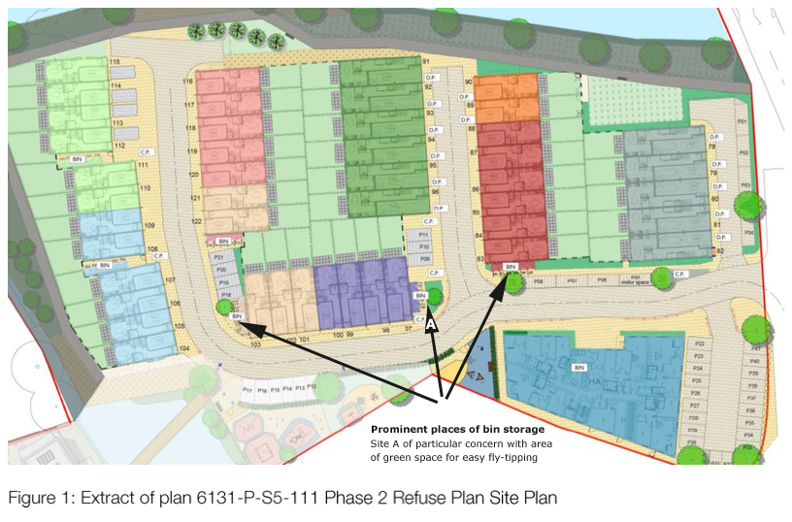

We are concerned that the revised locations of the bin storage, in such visually prominent locations directly under windows on flank elevations - as shown on drawing no. 6131-P-S5-400 Revision B - will result in adjacent residents being affected by smells, rats, insects and additional noise of usage.

How will the bin storage areas be maintained? Who will liaise with residents if their bin area becomes neglected? Who will monitor fly tipping?

We are concerned that bin storage areas located away from a resident’s actual property will only encourage these areas to be neglected.

The proposal to reduce 21 no. four bedroom houses to three bedroom houses, means that a whole floor level is being omitted to these houses and this has reduced internal utility space. As a consequence, the bin storage areas for these houses have been moved to external locations, which are detached from the houses. This compromises, in our opinion, the original waste strategy for the site, which was for bin storage areas to be provided within each garage. The original location for the bin storage, within the garages, was a more secure and an easier to maintain location for the bins.

REASON FOR OBJECTION NO.2 - BOUNDARY TREATMENTS

We note that no details have been provided, as part of this new application (DM2018/01687), of the fences to the private gardens.
We are concerned about how the fences will affect the views across the site, to the River Wandle. Since the original approved scheme provided communal gardens with open views to the river, which would have been used by all residents, we would like to know if any views have been retained.

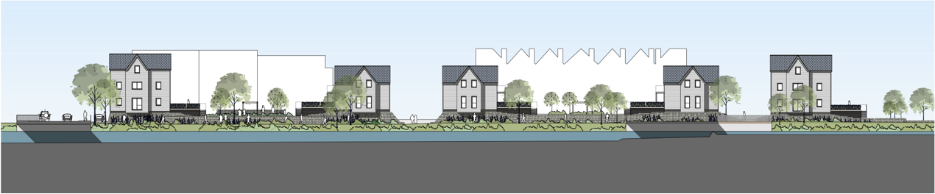
ORIGINAL APPROVED APPLICATION (C2013/68191)
Elevation Drawing no. A2426 S200 – August 2013 shows gable roofs, open community amenity spaces with views across the site and plenty of windows overlooking the river path.

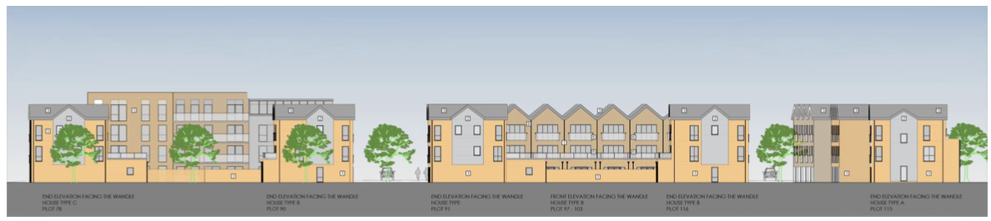
CURRENT PLANNING APPLICATION (DM2018/01687)
Elevation Drawing A 501- shows new gable roofs and more windows overlooking river path. However, no detail of height, length, material or what the square is of the boundary.

To put into context our frustration with this river footpath not being considered respectfully by the developers, we have shown the elevations of the two refused applications below:-

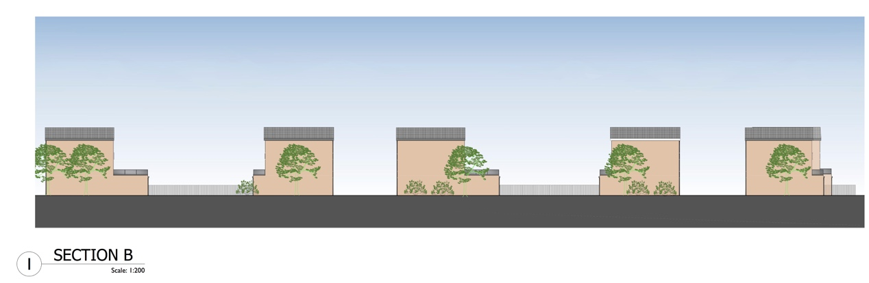
REFUSED PLANNING APPLICATION (C2017/77482)
Elevation Drawing no. 6131-P-S2-201 – June 2017 shows blank frontages of the side of houses and fence lines.

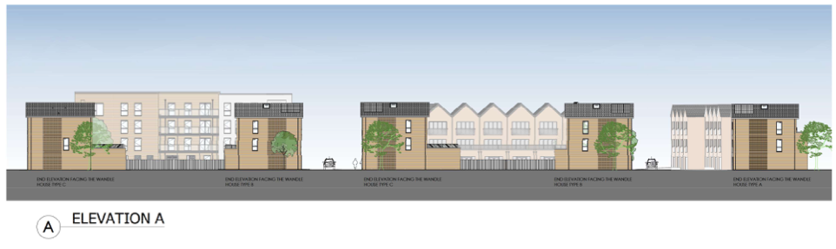
REFUSED APPLICATION (C2017/77482) & UPHELD ON APPEAL
Elevation Drawing no. 6131-P-S2-206 – January 2018 sent to us on 17 January 2018 after we asked why there was not an updated elevation drawing in their current planning application submission. It still shows an inadequate frontage facing the River Wandle path.

This new application (DM2018/01687) proposes to divide up the communal gardens into private gardens that are only for use of the individual houses. We note that in the Appeal Decision report, the Planning Inspector confirms that it may be acceptable to divide the communal gardens into private gardens, for the benefit of the individual houses, because sufficient outdoor space in the form of a balcony or terrace, which confirms with the London-wide Housing SPG, will be being provided to the apartments.
However, details of the proposed fencing to the private gardens should be provided, to confirm if any views have been retained - which in our opinion should be retained as much as possible for the benefit of all residents on the site.

CONCLUSION
Progress has been made on the design of the revised scheme, submitted with this new application (DM2018/01687), to retain some of the architectural features of the original approved scheme - such as the gables and windows added back to the flank elevations. These were removed in subsequent planning applications C2017/77482 and C2017/78472 (both were refused). However, we do not think that these amendments have been enough and that the revised scheme still does not make a positive architectural contribution to the wider community that is equal to the original approved scheme (C2013/68191).
We ask that you refuse this application.

Yours sincerely

JArmstrong

Julia Armstrong
Chair

