HACKBRIDGE AND BEDDINGTON CORNER NEIGHBOURHOOD DEVELOPMENT GROUP

(1) Application for re-designation of Neighbourhood Area

Neighbourhood Planning (General) Regulations 2012
Part 2 – Neighbourhood Area

APPLICATION FOR DESIGNATION AS A NEIGHBOURHOOD AREA

July 2022

Application for Designation as a Neighbourhood Area – Part 2 (5) (1)

The Hackbridge Neighbourhood Planning Area was formally designated on
18 September 2012 at the council’s Housing Economy and Business Committee and remained unchanged when redesignated in September 2018. As such the designation’s 5 years life span is set to expire in September 2022.

(a) Map identifying the area to which this application relates

Annex 2 below shows three maps:

Map 1 - refers to the current designated boundary area
Map 2 - shows the proposed new boundary area
Map 3 - highlights the new area to be included in the boundary

(b) a statement explaining why this area is considered appropriate to be designated as a neighbourhood area

Annex 2 expresses the consensus of the members of Hackbridge and Beddington Corner Neighbourhood Development Group that the ‘neighbourhood area’ as described and specified within this application should be amended.

The existing boundary was defined within the draft Hackbridge Masterplan 2009, which was widely consulted on at the time.

Boundary changes took place in the London Borough of Sutton that came into effect in May 2022, with a new Hackbridge Ward being created. We wish to align to the northern boundary of this new Ward map, which increases our boundary slightly. The proposed piece of land is non-residential and can be seen in Annex 2, Map 3.

The east and west boundaries are the same as the Hackbridge Ward Map, but the southern boundary is different. We do not propose to align this with the new Hackbridge Ward map as it is important that we retain our boundary as this area falls within Hackbridge Area of Potential Intensification. In addition, the residents in this area have been particularly active in neighbourhood planning for the past 10 years and would be disrespectful for them not to be able to continue to be proactive and have a say about the future of Hackbridge.

(c) a statement that the organisation or body making the area application is a relevant body for the purpose of section 61G of the 1990 Act.

Following the selection of Hackbridge by Government as a Neighbourhood Planning Front Runner in early 2011, the Hackbridge community have worked with Sutton Council and produced a neighbourhood plan for the Hackbridge and Beddington Corner Area.

The Hackbridge and Beddington Corner Neighbourhood Development Group has an open membership which exceeds 21 individuals, including local residents, local businesses, individuals who work in the area and elected Ward Councillors. In addition, it has an elected Chair, Vice-Chair, Secretary and Treasurer.

The Hackbridge and Beddington Corner NDG continue to meet to progress the implementation of the Neighbourhood Plan and preliminary discussions for its renewal.

The minutes of meetings are published on https://hackbridgendg.com/ , along with other supporting information and governance.

It therefore considers itself a relevant body for the purposes of Section 61G of the 1990 Act.

ANNEX 2
Map 1 - Existing approved boundary map

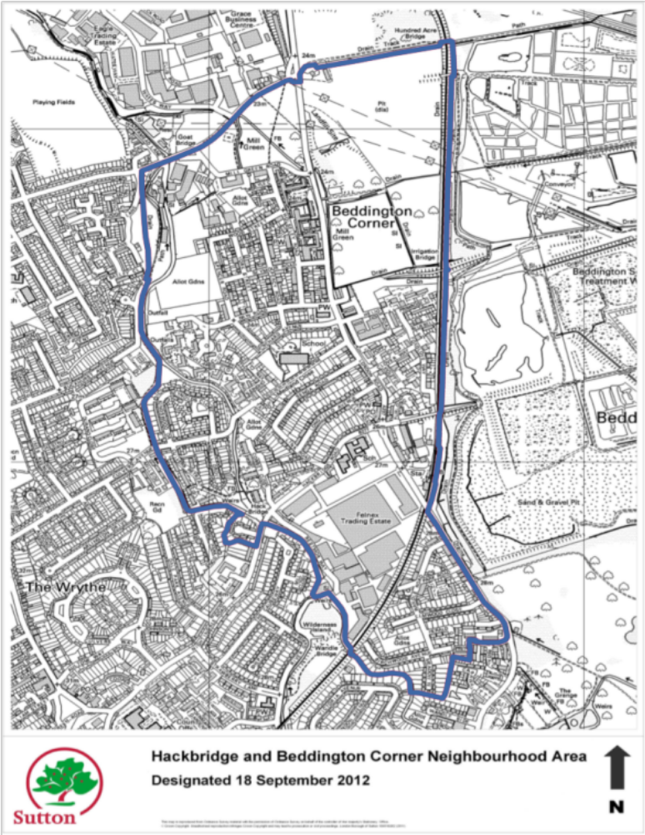

Map 2 - Proposed boundary map
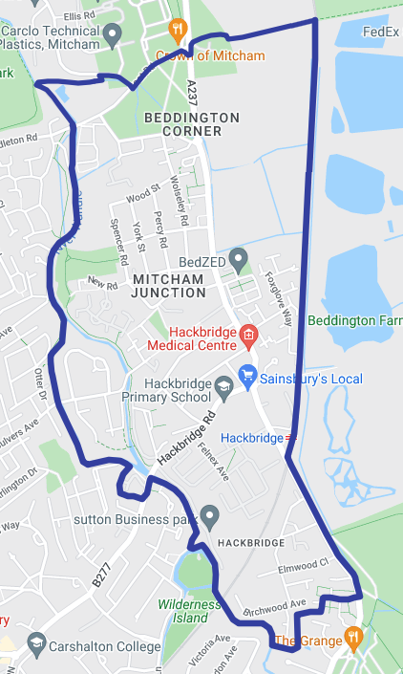

Map 3 – highlighted area to be incorporated

